Face Recognition System

Installation Guide

1. At first download the software from provided link.
2. After download it install (Please don’t change the installation path (Recommended))
3. After successfully install go to the installation path (Default : C:\ Face_Recognition)
4. Find “Face_Recognition.exe” executable file and make a shortcut for this file to the Desktop.
5. Now cut or copy the shortcut .
6. Then press “win + R” button at the same time.
7. Then type “shell:startup” and hit enter.

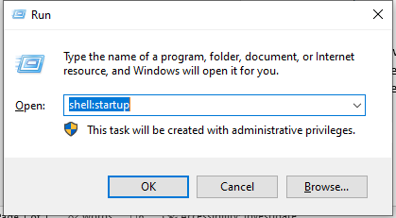

1. After opening please paste your shortcut here.
2. And double click to this shortcut.
3. Now you are ready for face recognition.